L-DCS - Local Departure Control System
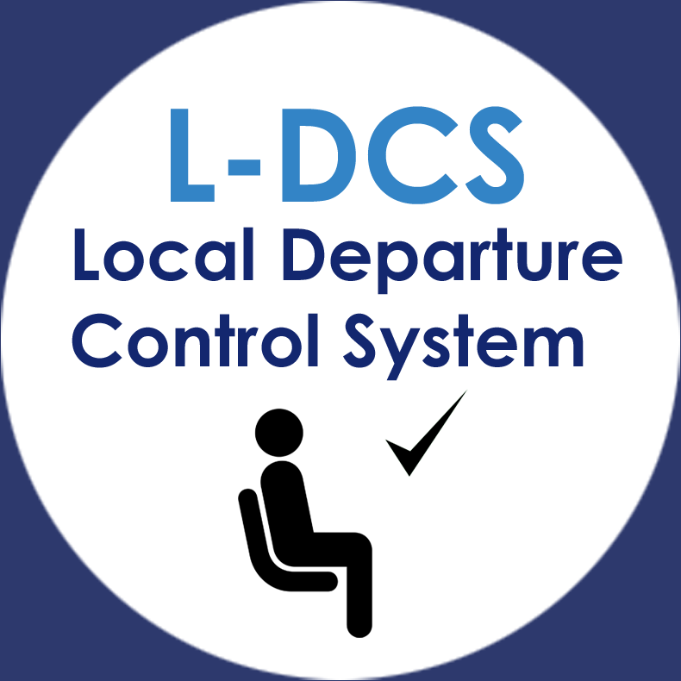
Presentation | L-DCS Overview  L-DCS - Technical presentation

